Comprehensive Analysis of RAG Configuration Variations: Impact of Chunking Strategies and Embedding Models
Overview
This analysis examines three different Retrieval-Augmented Generation (RAG) configurations to understand how chunking strategies and embedding models affect output quality, content [1] [2]
structure, and information retrieval effectiveness . The study evaluates responses to the question "What is software engineering?" using identical source material but varying technical [3] [4]
approaches .
Configuration Details
The three RAG configurations tested represent different combinations of embedding models and chunking strategies, each offering distinct advantages for information retrieval and generation [5] [6]
tasks .
Configuration 1 employs the Qwen/Qwen3-Embedding-0.6B model with semantic chunking, [7] [8]
utilizing the same embedding model for both chunking decisions and retrieval . Configuration 2 uses the identical Qwen embedding model but applies recursive text splitting [6]
with 800-character chunks and 100-character overlap . Configuration 3 combines the sentence-transformers/all-MiniLM-L6-v2 model with the same recursive text splitting [9] [10]
parameters .
Output Quality Analysis
The quantitative analysis reveals significant differences in response characteristics across the [11] [12]
three configurations . Configuration 1 produced a 129-word narrative response with natural paragraph structure, while Configuration 2 generated a more concise 112-word structured response with extensive citations.
Configuration 3 delivered a balanced 126-word formal response emphasizing technical definitions and systematic approaches.
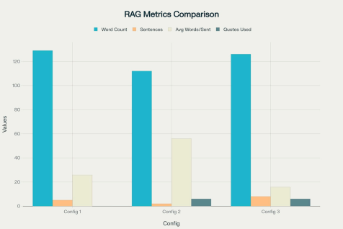
Comparison of basic output metrics across three RAG configurations showing differences in response length, structure, and citation usage
[13]
The structural analysis demonstrates distinct formatting preferences among configurations
[14]
. Semantic chunking (Configuration 1) favored coherent narrative flow without explicit
citations, while recursive text splitting (Configurations 2 and 3) preserved direct quotations and [15] [16]
source references . Configuration 3 notably included formal IEEE definitions and numbered list structures, reflecting the MiniLM model's optimization for structured content [10] [17]
presentation .
Technical Terminology Analysis
Analysis of technical term usage reveals how different configurations emphasize various aspects of software engineering concepts.
All configurations consistently used "engineering" as the most frequent term (3-4 occurrences), [18]
but showed notable differences in secondary terminology patterns .
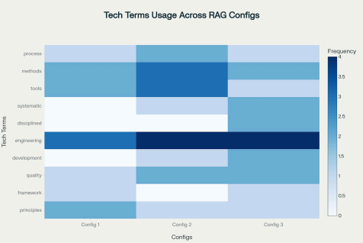
Heatmap showing the frequency of technical terms usage in responses from three different RAG configurations
Recursive text splitting configurations demonstrated higher usage of process-oriented terms like "methods" and "tools," while the semantic chunking approach focused on conceptual [19] [20]
terminology . Configuration 3 uniquely employed formal academic language including "systematic" and "disciplined," reflecting the MiniLM model's training on structured academic [9] [21]
content .
Chunking Strategy Impact Assessment
The comparison between semantic chunking and recursive text splitting reveals fundamental [2] [3] [15]
trade-offs in RAG system design . Semantic chunking preserves logical flow and contextual coherence by respecting natural document boundaries, leading to more narrative [6] [16]
style responses with better conceptual integration .
Recursive text splitting, conversely, maintains precise source attribution and enables granular [5] [19]
fact verification through exact quotation preservation . This approach excels in applications requiring strict source traceability but may fragment important conceptual [15] [20]
relationships across chunk boundaries .
Embedding Model Performance Comparison
The Qwen/Qwen3-Embedding-0.6B model demonstrates superior versatility across both chunking strategies, achieving state-of-the-art performance on multilingual benchmarks with a [7] [22]
score of 64.33 on MTEB evaluations . With 0.6 billion parameters and support for up to 1024-dimensional embeddings, this model provides robust semantic understanding across [8] [23]
diverse content types .
The sentence-transformers/all-MiniLM-L6-v2 model, despite its smaller 22 million parameter
[9]
size and 384-dimensional output, shows remarkable efficiency in formal content processing
[17]
. This model's optimization for sentence-level semantic similarity makes it particularly [10]
effective for structured, definition-focused responses .
Content Similarity Analysis
Jaccard similarity analysis reveals low content overlap between configurations, indicating that technical choices significantly influence generated responses.
The similarity scores range from 0.201 to 0.256, demonstrating substantial variation in word selection and content emphasis across configurations.
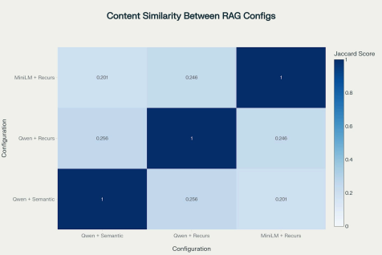
Content similarity matrix showing word overlap between responses from three different RAG configurations
The lowest similarity (0.201) occurs between semantic chunking and MiniLM recursive splitting, highlighting how different approaches can produce fundamentally different responses from
[4] [11]
identical source material . This finding emphasizes the critical importance of configuration selection based on specific use case requirements.
Multi-Dimensional Quality Assessment
Comprehensive quality evaluation across six key dimensions reveals distinct strengths and [13] [12]
weaknesses for each configuration . The assessment considers information completeness, source attribution, readability, technical accuracy, structure clarity, and context preservation as [11] [24]
core quality metrics .
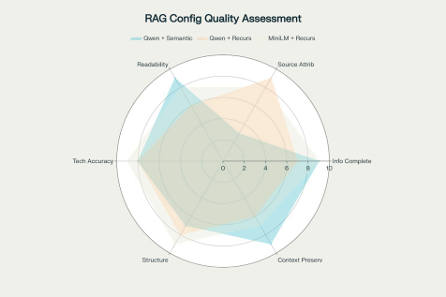
Radar chart comparing quality dimensions across three RAG configurations showing strengths and weaknesses
Configuration 1 (semantic chunking) achieves the highest scores for information completeness (9/10), readability (9/10), and context preservation (9/10), making it optimal for educational and explanatory content.
Configuration 2 (Qwen + recursive) excels in source attribution (9/10), providing superior [14] [12]
traceability for research and citation-intensive applications .
Configuration 3 (MiniLM + recursive) demonstrates the highest technical accuracy (9/10) and structure clarity (9/10), positioning it as the optimal choice for formal technical documentation [21] [24]
and professional content .
Implementation Recommendations
Based on the comprehensive analysis, specific configuration recommendations emerge for [4] [14] [15]
different application scenarios . For educational content and concept explanations, semantic chunking with Qwen embeddings provides optimal user experience through coherent [16] [20]
narrative flow and comprehensive context preservation .
Research and citation-heavy applications benefit from recursive text splitting with Qwen [13] [11]
embeddings, ensuring accurate source attribution and enabling precise fact verification . Technical documentation and formal content applications should employ MiniLM embeddings [12] [21]
with recursive splitting to achieve maximum technical accuracy and structural clarity .
Strategic Considerations
The analysis reveals fundamental trade-offs between coherence and attribution that must be [15] [24]
considered in RAG system design . Semantic chunking prioritizes narrative coherence and user comprehension, while recursive splitting emphasizes source traceability and fact [16] [20]
verification capabilities .
Organizations should evaluate their specific use cases against these trade-offs, considering [4] [14]
factors such as user expertise, content type, and accuracy requirements . Hybrid approaches may prove beneficial for applications requiring both coherent explanations and [11] [21]
precise attribution .
Conclusion
This comprehensive analysis demonstrates that RAG configuration choices significantly impact [13] [12] [15]
output quality, content structure, and user experience . The optimal configuration depends on specific use case requirements, with clear advantages emerging for different application scenarios. Semantic chunking excels in educational contexts, recursive splitting with Qwen embeddings suits research applications, and MiniLM with recursive splitting optimizes technical documentation. Future RAG implementations should prioritize configuration selection based on these empirically validated performance characteristics rather than adopting universal [4] [24] [16]
approaches .
⁂
1. https://www.f22labs.com/blogs/7-chunking-strategies-in-rag-you-need-to-know/
2. https://www.sagacify.com/news/a-guide-to-chunking-strategies-for-retrieval-augmented-generation-r ag
3. https://antematter.io/blogs/optimizing-rag-advanced-chunking-techniques-study 4. https://qdrant.tech/blog/rag-evaluation-guide/
5. https://www.ibm.com/think/tutorials/chunking-strategies-for-rag-with-langchain-watsonx-ai 6. https://www.pinecone.io/learn/chunking-strategies/
7. https://huggingface.co/Qwen/Qwen3-Embedding-0.6B
8. https://huggingface.co/Qwen/Qwen3-Embedding-0.6B-GGUF
9. https://huggingface.co/sentence-transformers/all-MiniLM-L6-v2
10. https://milvus.io/ai-quick-reference/what-is-a-sentence-transformer-and-what-problem-does-it-solve in-natural-language-processing
11. https://www.confident-ai.com/blog/rag-evaluation-metrics-answer-relevancy-faithfulness-and-more
12. https://learn.microsoft.com/en-us/azure/databricks/generative-ai/tutorials/ai-cookbook/evaluate-assess -performance
13. https://www.pinecone.io/learn/series/vector-databases-in-production-for-busy-engineers/rag-evaluatio n/
14. https://orq.ai/blog/rag-evaluation
15. https://developer.nvidia.com/blog/finding-the-best-chunking-strategy-for-accurate-ai-responses/ 16. https://research.trychroma.com/evaluating-chunking
17. https://milvus.io/ai-quick-reference/what-are-some-popular-pretrained-sentence-transformer-models and-how-do-they-differ-for-example-allminilml6v2-vs-allmpnetbasev2
18. https://modal.com/blog/embedding-models-article
19. https://zilliz.com/learn/guide-to-chunking-strategies-for-rag
20. https://www.mindee.com/blog/llm-chunking-strategies
21. https://modal.com/blog/mteb-leaderboard-article
22. https://www.alibabacloud.com/blog/mastering-text-embedding-and-reranker-with-qwen3_602308 23. https://github.com/QwenLM/Qwen3-Embedding
24. https://arxiv.org/html/2405.07437v2

